Specific Learning Disability (SLD)
- Chunk tasks into 10-15 minutes of work at a time.
- Use a timer to show how much time the child has left to work. You can use your timer on your phone, a kitchen timer, etc.
- Present instructions visually and verbally, repeat instructions/directions in a different manner (ex: If the directions are written, ask your child to say them out loud or provide verbal instructions for your child).
- Break large tasks into small steps - demonstrate/model the steps and have the child do the steps, one at a time.
- Use a number line, calculator, or math facts chart to aid in basic math calculation.
- Allow the use of counters which can easily be found around the house as counters, ex. pennies or M&Ms.
- Use paired reading techniques which involve both the parent and child reading aloud together. Stop reading if the child misreads the word, point to the word, pronounce it, have the child reread the word and when correct, continue reading through the passage.
- Practice reading by allowing the student to pick out high-interest books.
- Visual Schedule/Checklist (sample provided - Figure 1)
- Break Card (sample provided - Figure 2)

Figure 1. Sample Visual Schedule/Checklist

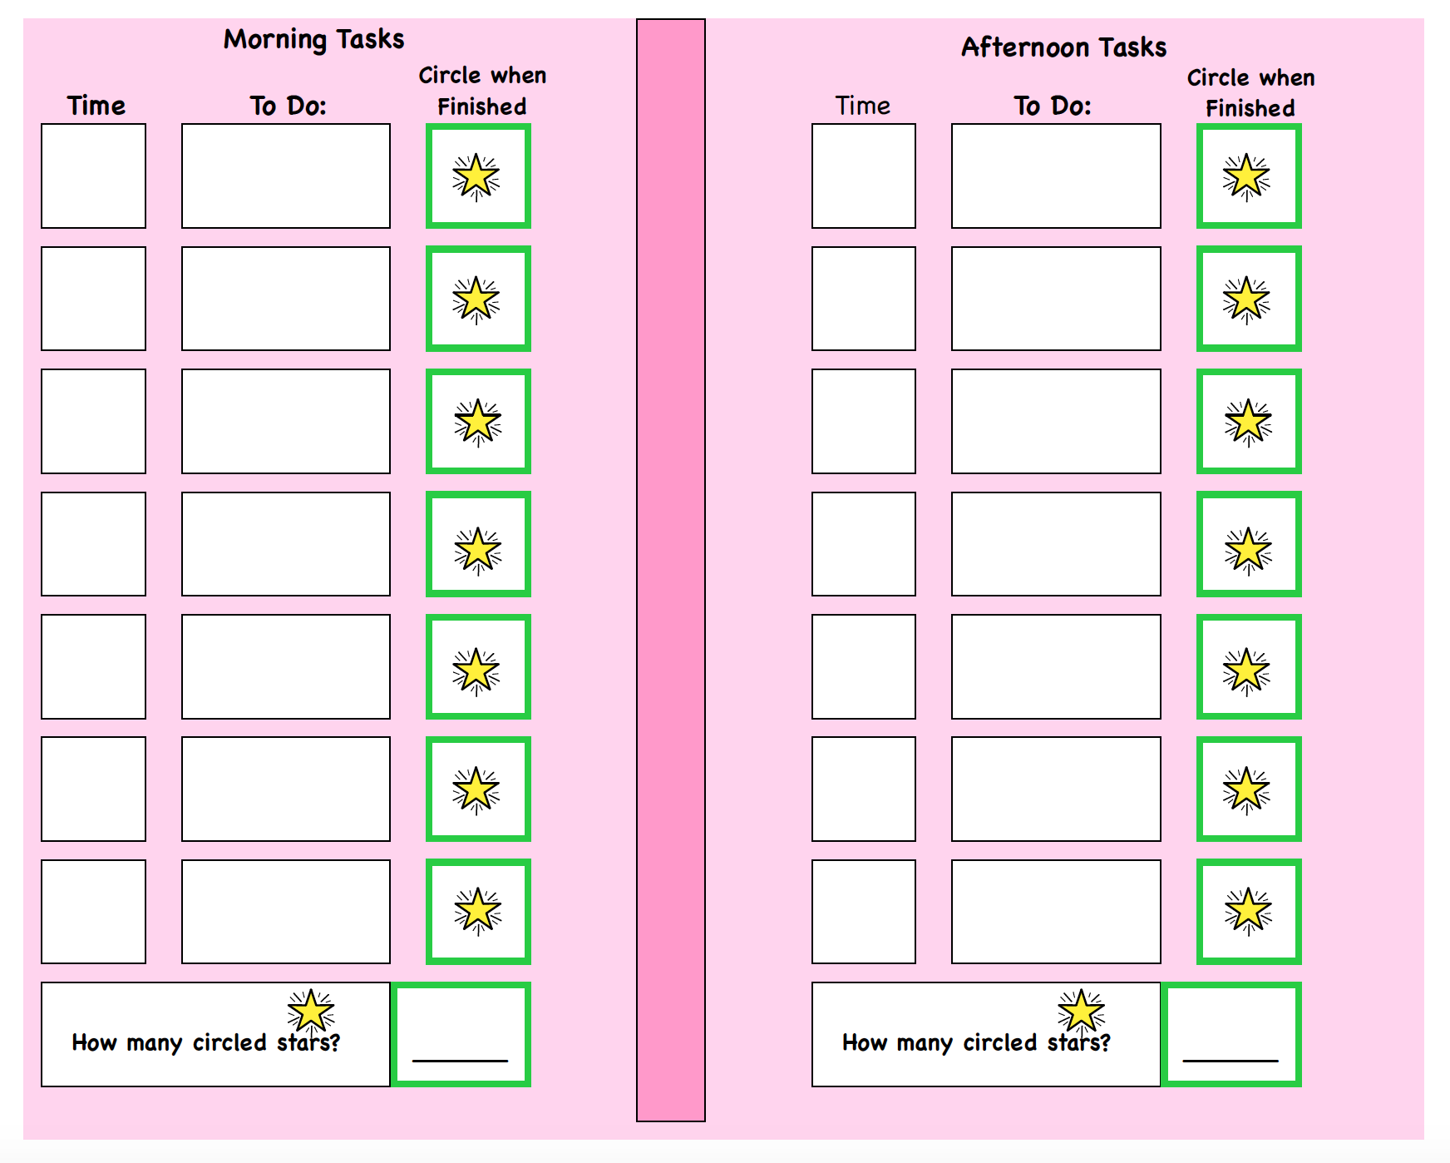

Figure 2. Sample Break Card

