Intellectual Disability
- Engage in frequent repetition of concepts. Explain concepts in different ways (i.e. visually and verbally, model)
- Break large tasks into small steps - demonstrate/model the steps and have the child do the steps, one at a time
- Spend this time practicing functional activities (i.e., feeding themselves, personal hygiene, helping to set the table, cleaning their room, etc.)
- Chunk tasks into 10-15 minutes of work at a time
- Use a timer to show how much time the child has left to work. You can use your timer on your phone, a kitchen timer, etc.
- Break up the child’s schedule with physical and sitting down activities
- Use hands-on and multi-sensory activities to reinforce learning. For instance, spread shaving cream on a baking tray and encourage the child to practice writing their letters or spelling words in the shaving cream. Dry flavored jello mix could also be used.
- Reinforce learning by providing real-life examples.
- Read to the child and with the child
- Play games to reinforce skills such as counting (ex. Move 5 spaces on a game board) or color recognition (ex. move to the red square).
- Visual Schedule/Checklist (sample provided - Figure 1)
- First-Then Chart (sample provided with pictures - Figures 2 & 3)
- Break Card (sample provided - Figure 4)

Figure 1. Sample Visual Schedule/Checklist

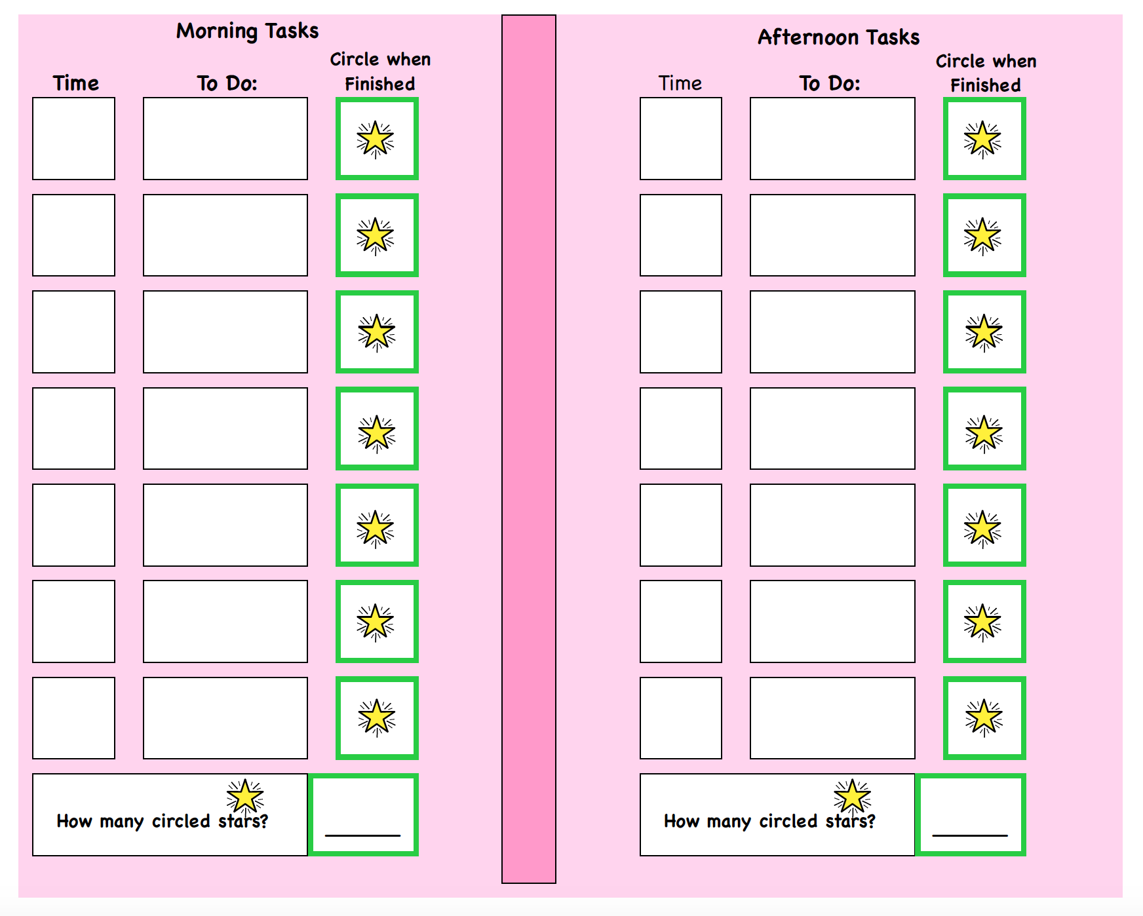

Figure 2. Sample First-Then Chart
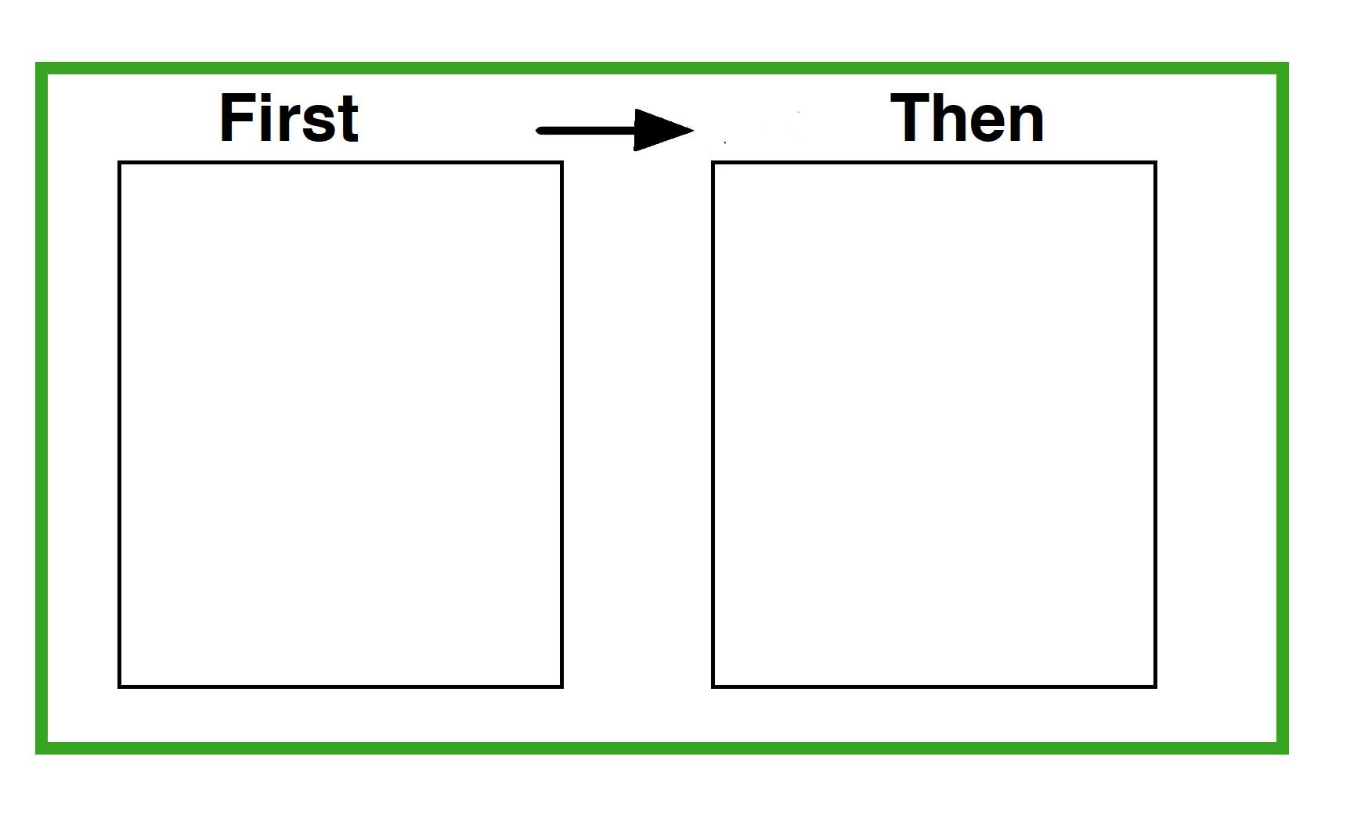

Figure 3. Images for First-Then Chart

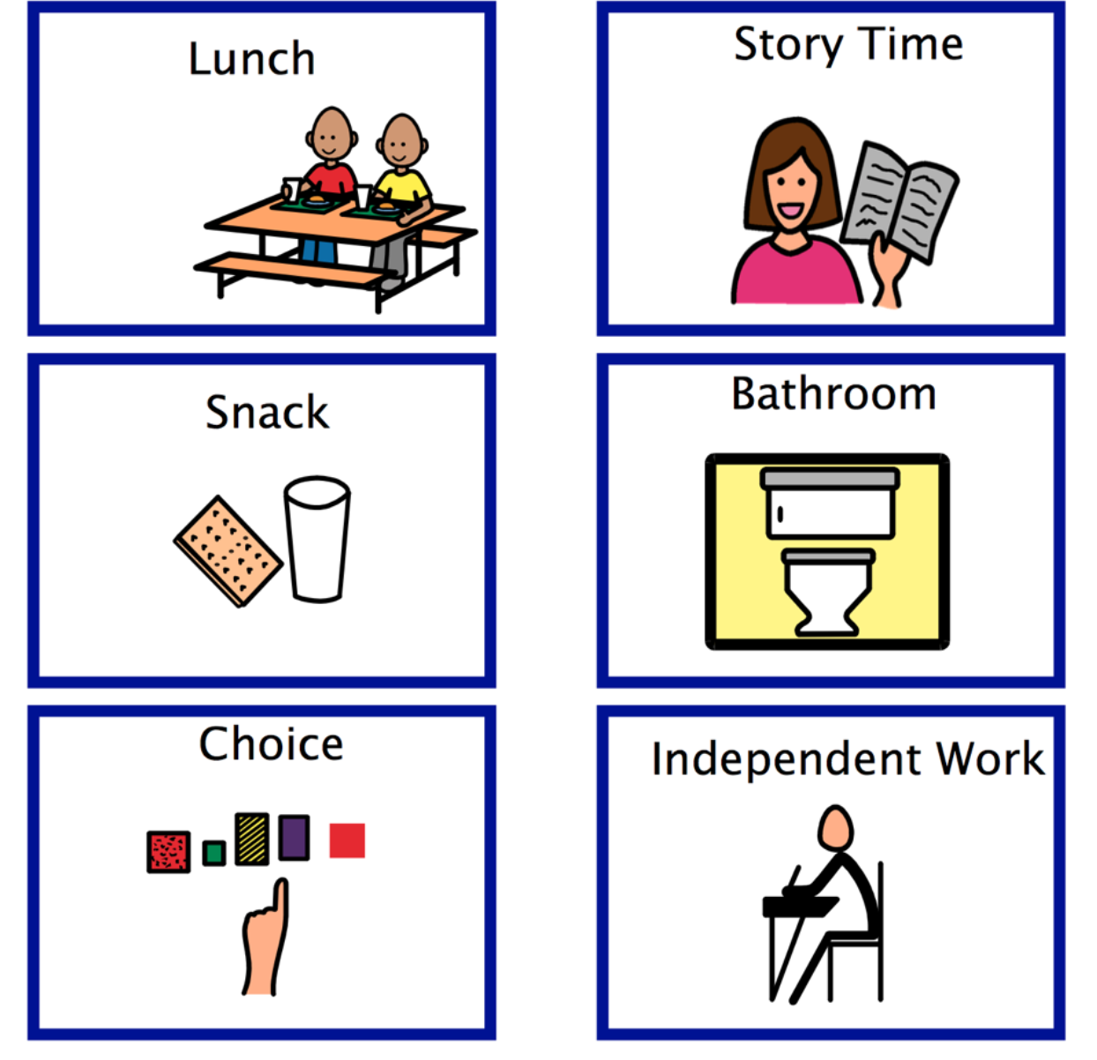
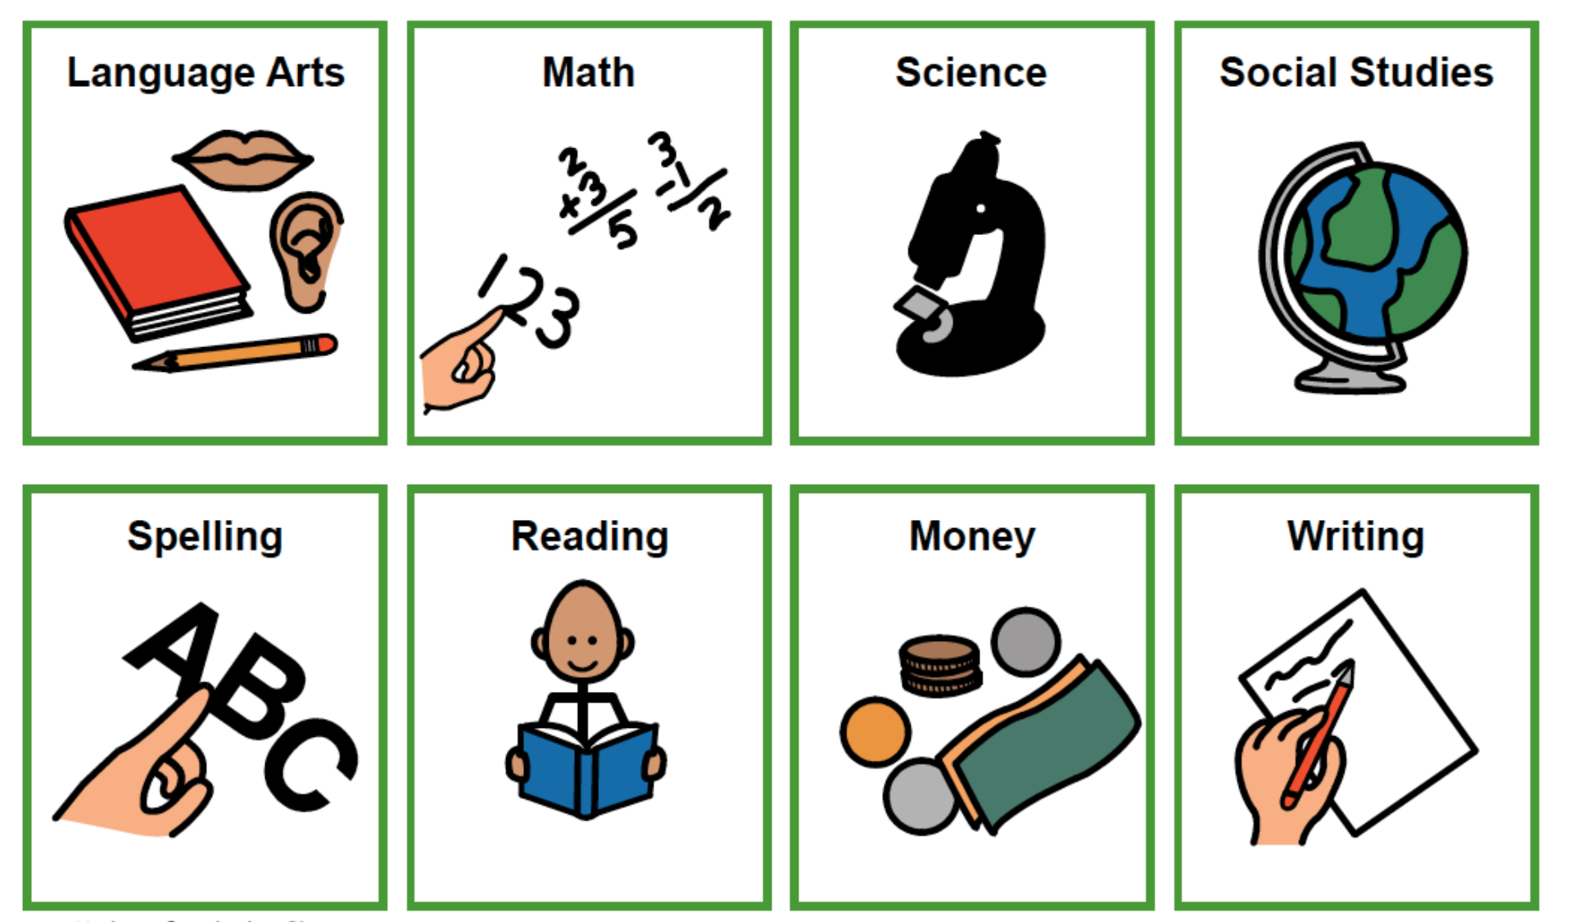

Figure 4. Sample Break Card

