Emotional Disturbance (ED)
- Exercise - take walks with your child as a break.
- Provide your child with reinforcement after they complete a task or assignment (ex: stickers, time to play, a fun activity with you or others, see behavior charts/other behavioral strategies below).
- Chunk tasks into 10-15 minutes of work at a time.
- Use a timer to show how much time the child has left to work. You can use your timer on your phone, a kitchen timer, etc.
- Practice deep breathing and “belly breathing” to reduce stress and anxiety.
- Set small, easily achievable goals.
- Create a To-Do List for assignments or tasks and encourage the child to cross off items as they are complete to provide a sense of accomplishment.
- Use genuine and frequent praise to motivate and encourage compliance to activities.
- Allow the child the opportunity to choose the order in which to complete tasks or intersperse challenging tasks with easier tasks.
- Visual Schedule/Checklist (sample provided - Figure 1)
- First-Then Chart (sample provided with pictures - Figures 2 & 3)
- Behavior Star Chart (sample provided - Figure 4)
- Behavior Awareness Cards (sample provided - Figure 5)
- Break Card (sample provided - Figure 6)

Figure 1. Sample Visual Schedule/Checklist

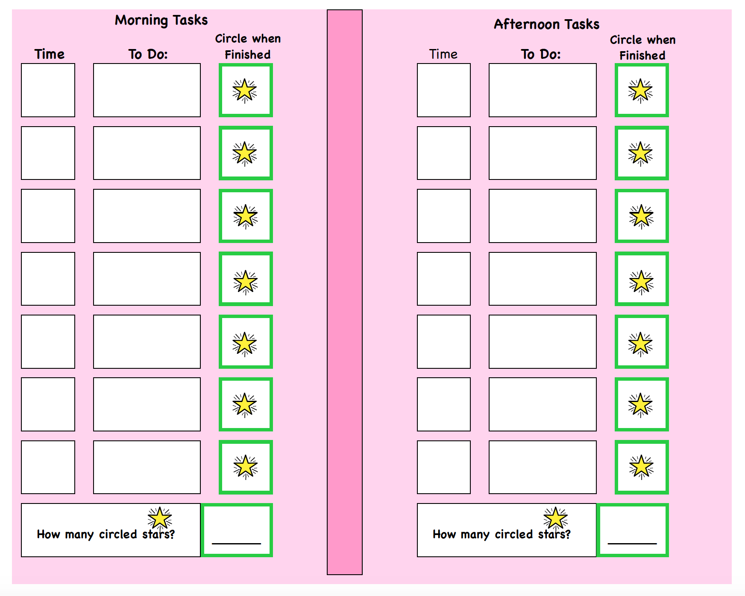

Figure 2. Sample First-Then Chart
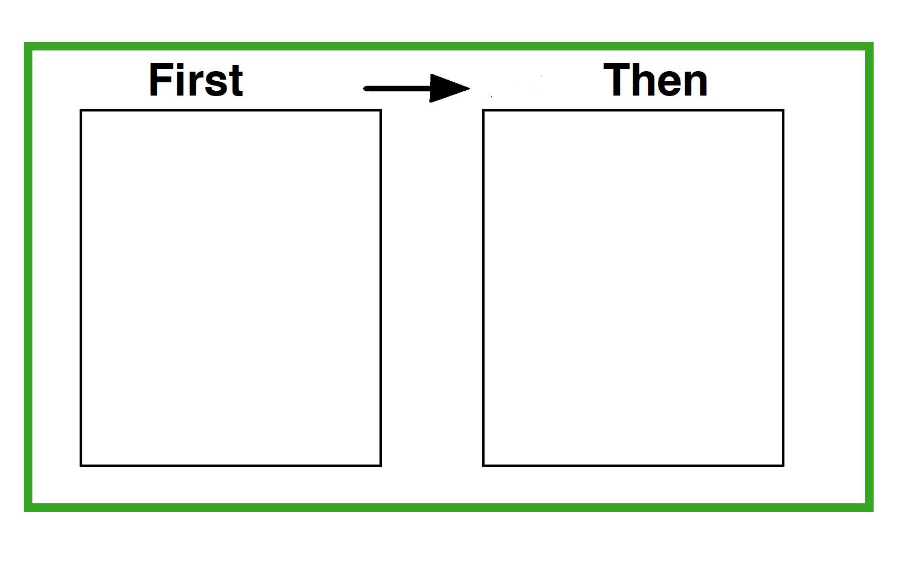

Figure 3. Images for First-Then Chart

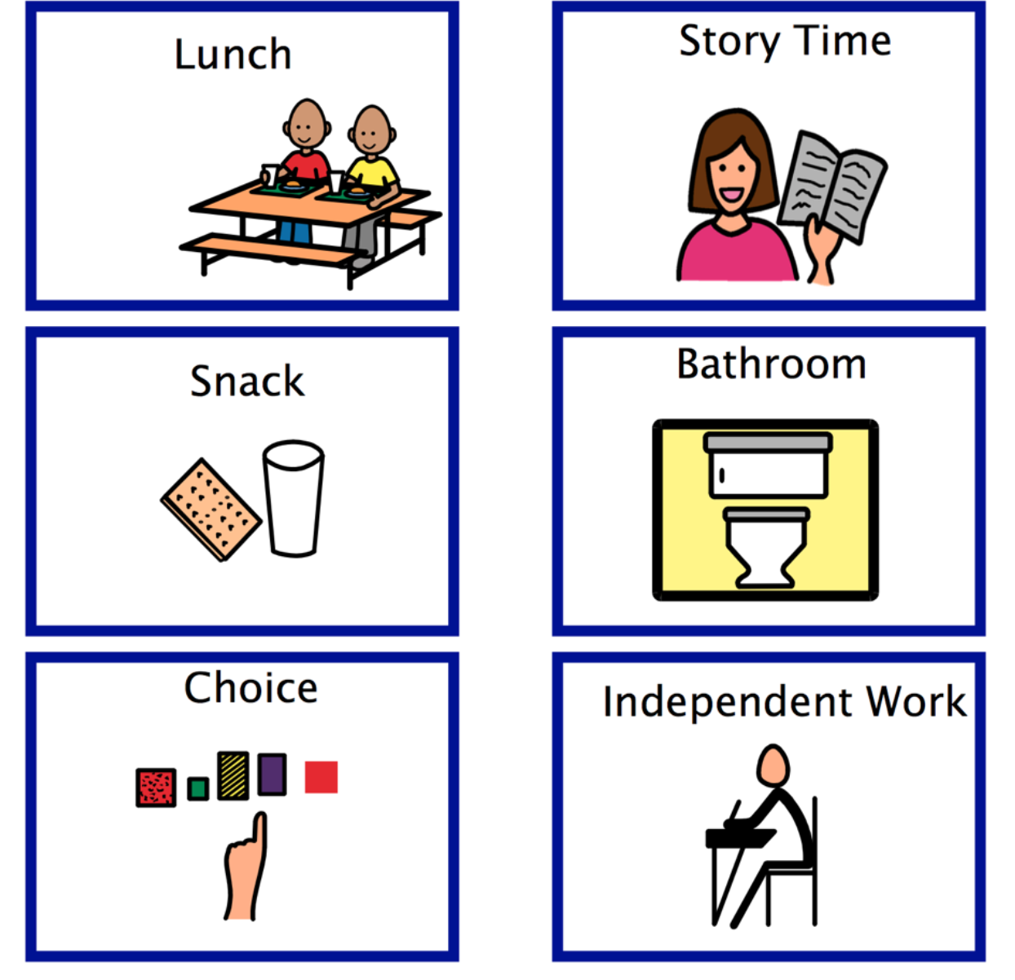
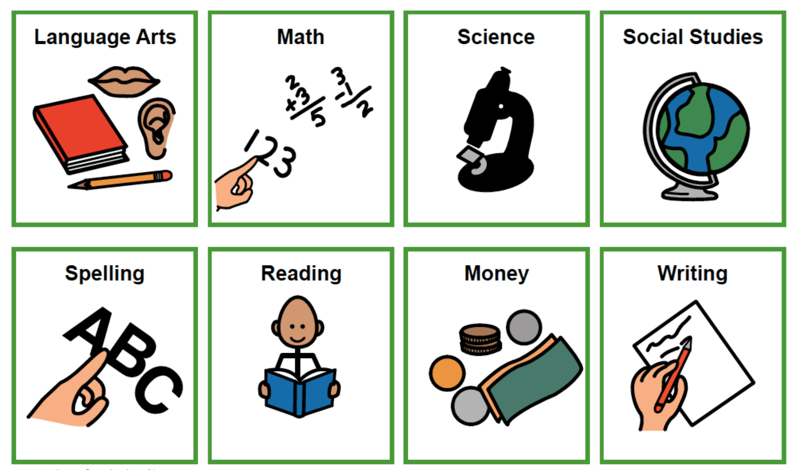

Figure 4. Sample Behavior Star Chart

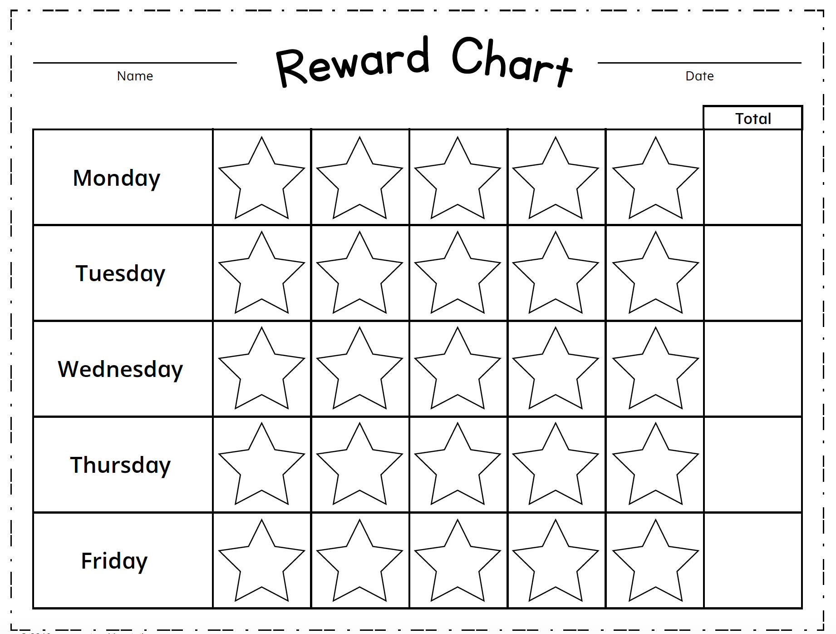

Figure 5. Sample Behavior Awareness Cards

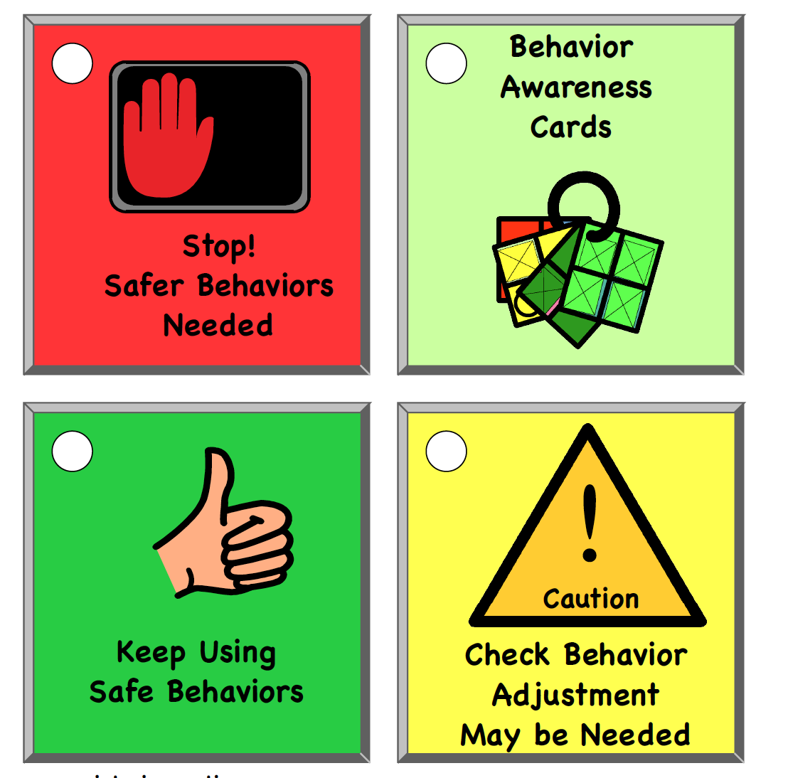

Figure 6. Sample Break Card

