Autism Spectrum Disorder (ASD)
- https://icahn.mssm.edu/research/seaver/resources/covid-19-autism-resources
- Chunk tasks into 10-15 minutes of work at a time
- Use a timer to show how much time the child has left to work. You can use your timer on your phone, a kitchen timer, etc.
- Try to develop and maintain a daily routine and provide as much structure as possible, notify your child of any changes to their schedule or routine beforehand, if possible. Try to keep their schedule similar to their in-person school schedule and routine (ex: wake-up, eat breakfast, work on the academic tasks in the order they attended their classes/based upon their school schedule)
- Visual Schedule/Checklist (sample provided - Figure 1)
- First-Then Chart (sample provided with pictures - Figures 2 & 3)
- Behavior Star Chart (sample provided - Figure 4)
- Behavior Awareness Cards (sample provided - Figure 5)
- Break Card (sample provided - Figure 6)

Figure 1. Sample Visual Schedule/Checklist

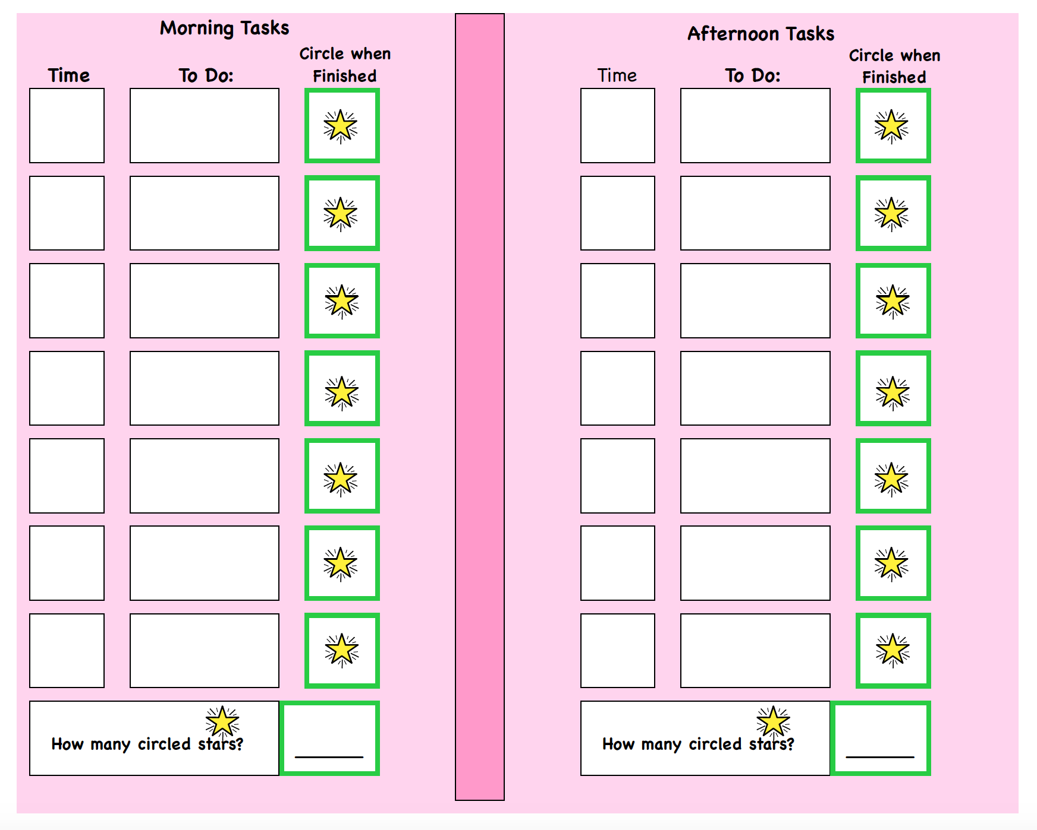

Figure 2. Sample First-Then Chart
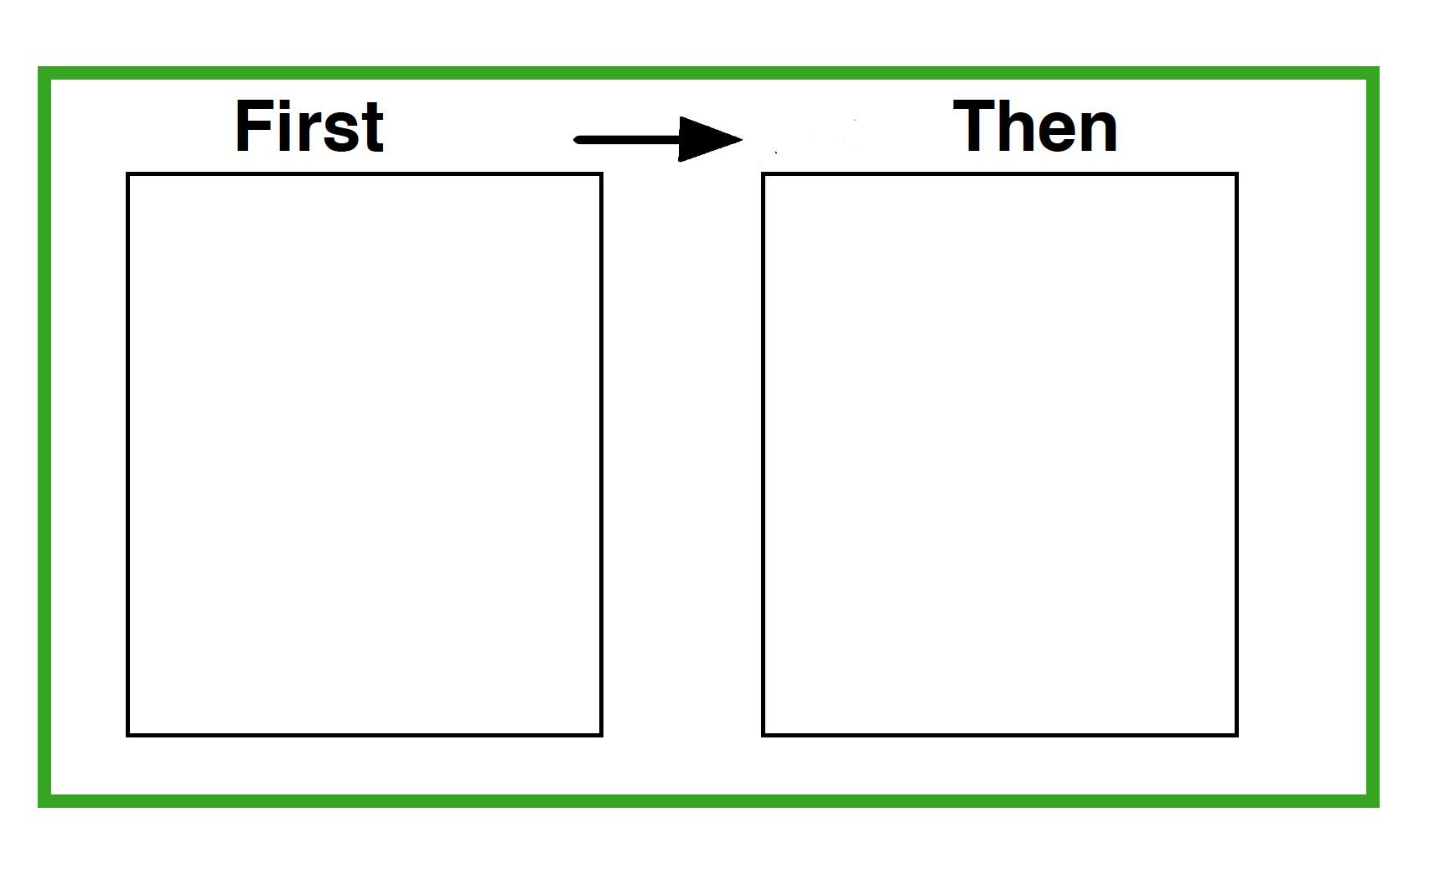

Figure 3. Images for First-Then Chart

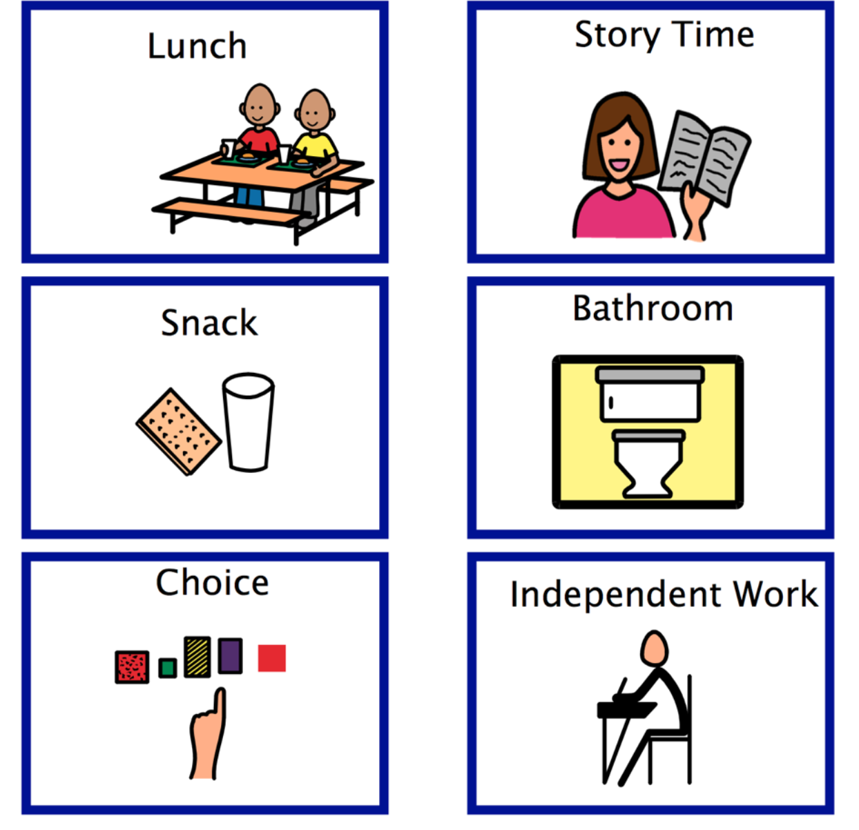
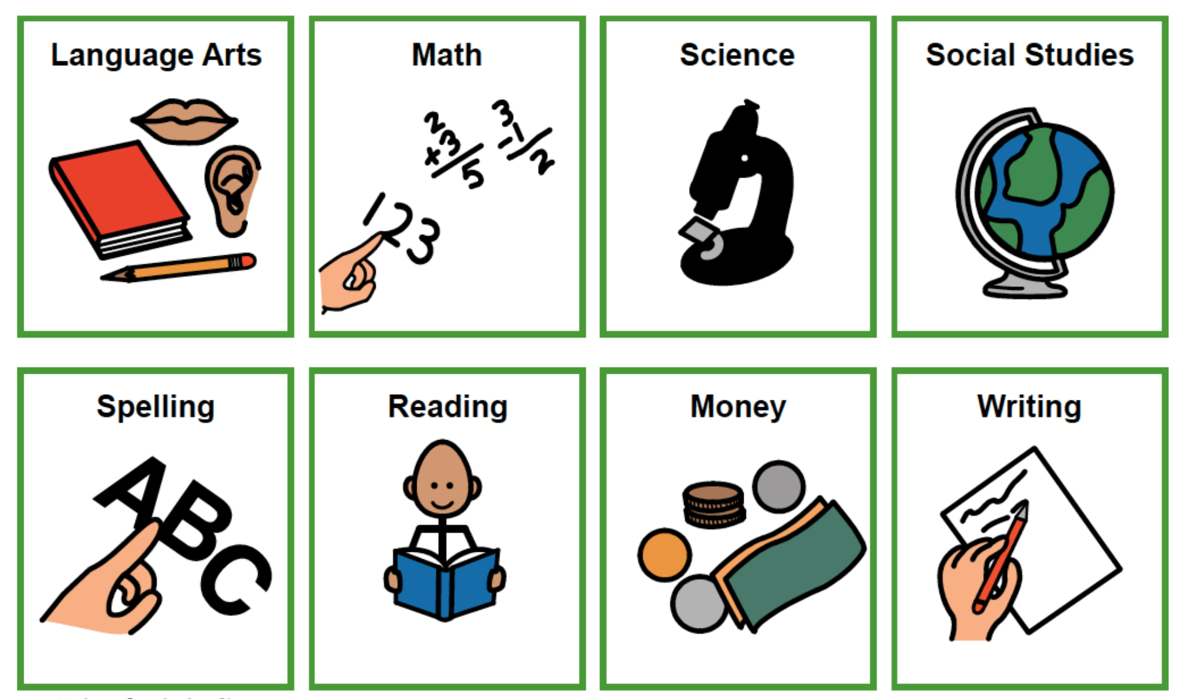

Figure 4. Sample Behavior Star Chart

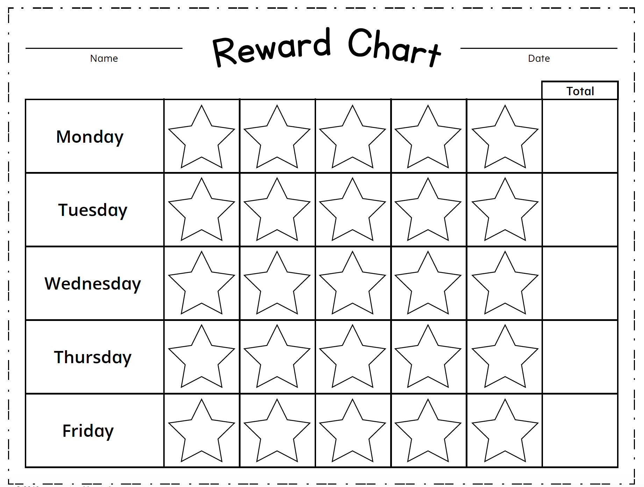

Figure 5. Sample Behavior Awareness Cards

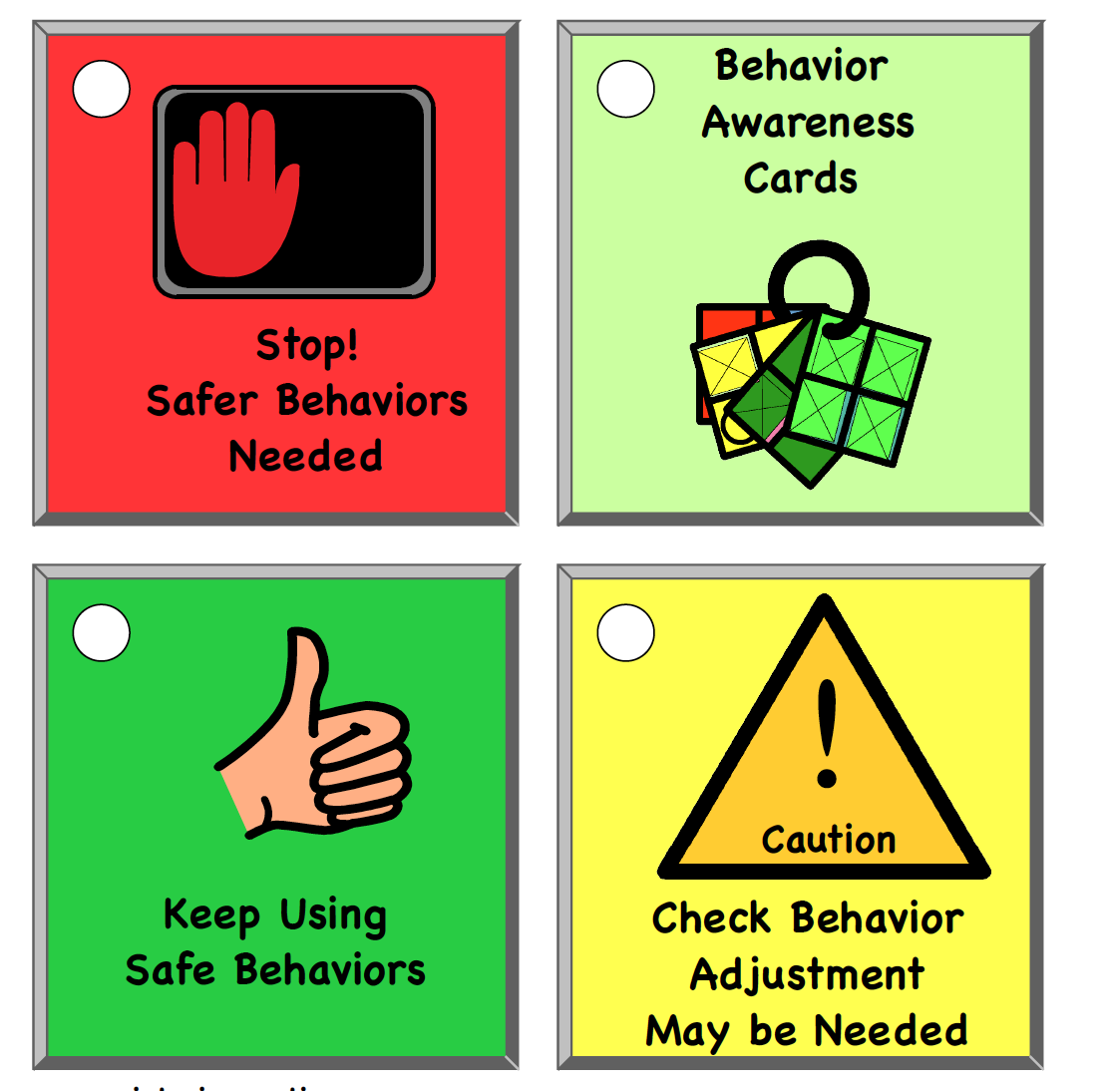

Figure 6. Sample Break Card

