Attention-Deficit/Hyperactivity Disorder (ADHD)

- Chunk tasks into 10-15 minutes of work at a time.
- Use a timer to show how much time the child has left to work. You can use your timer on your phone, a kitchen timer, etc.
- Break up the child’s schedule with physical and sitting down activities. Allow your child to have short movement breaks.
- Have your child sit at a stable surface that mimics a desk as much as possible (ex: kitchen table, dining room table, kitchen island, office desk, etc.).
- Limit distractions during work time (ex: try to make sure your child is not accessing non-school materials/sites on the internet and on their iPad or computer, have the television and other electronics off, make sure they do not have access to their cellphone/cellphone is turned off, have your child work in a separate room without others while they are working on school work, close blinds/curtains, etc.).
- Provide a quick tap on the shoulder/table or provide another quick prompt when your child is inattentive to their current task.
- Visual Schedule/Checklist (sample provided - Figure 1)
- First-Then Chart (sample provided with pictures - Figures 2 & 3)
- Behavior Star Chart (sample provided - Figure 4)
- Behavior Awareness Cards (sample provided - Figure 5)
- Break Card (sample provided - Figure 6)

Figure 1. Sample Visual Schedule/Checklist

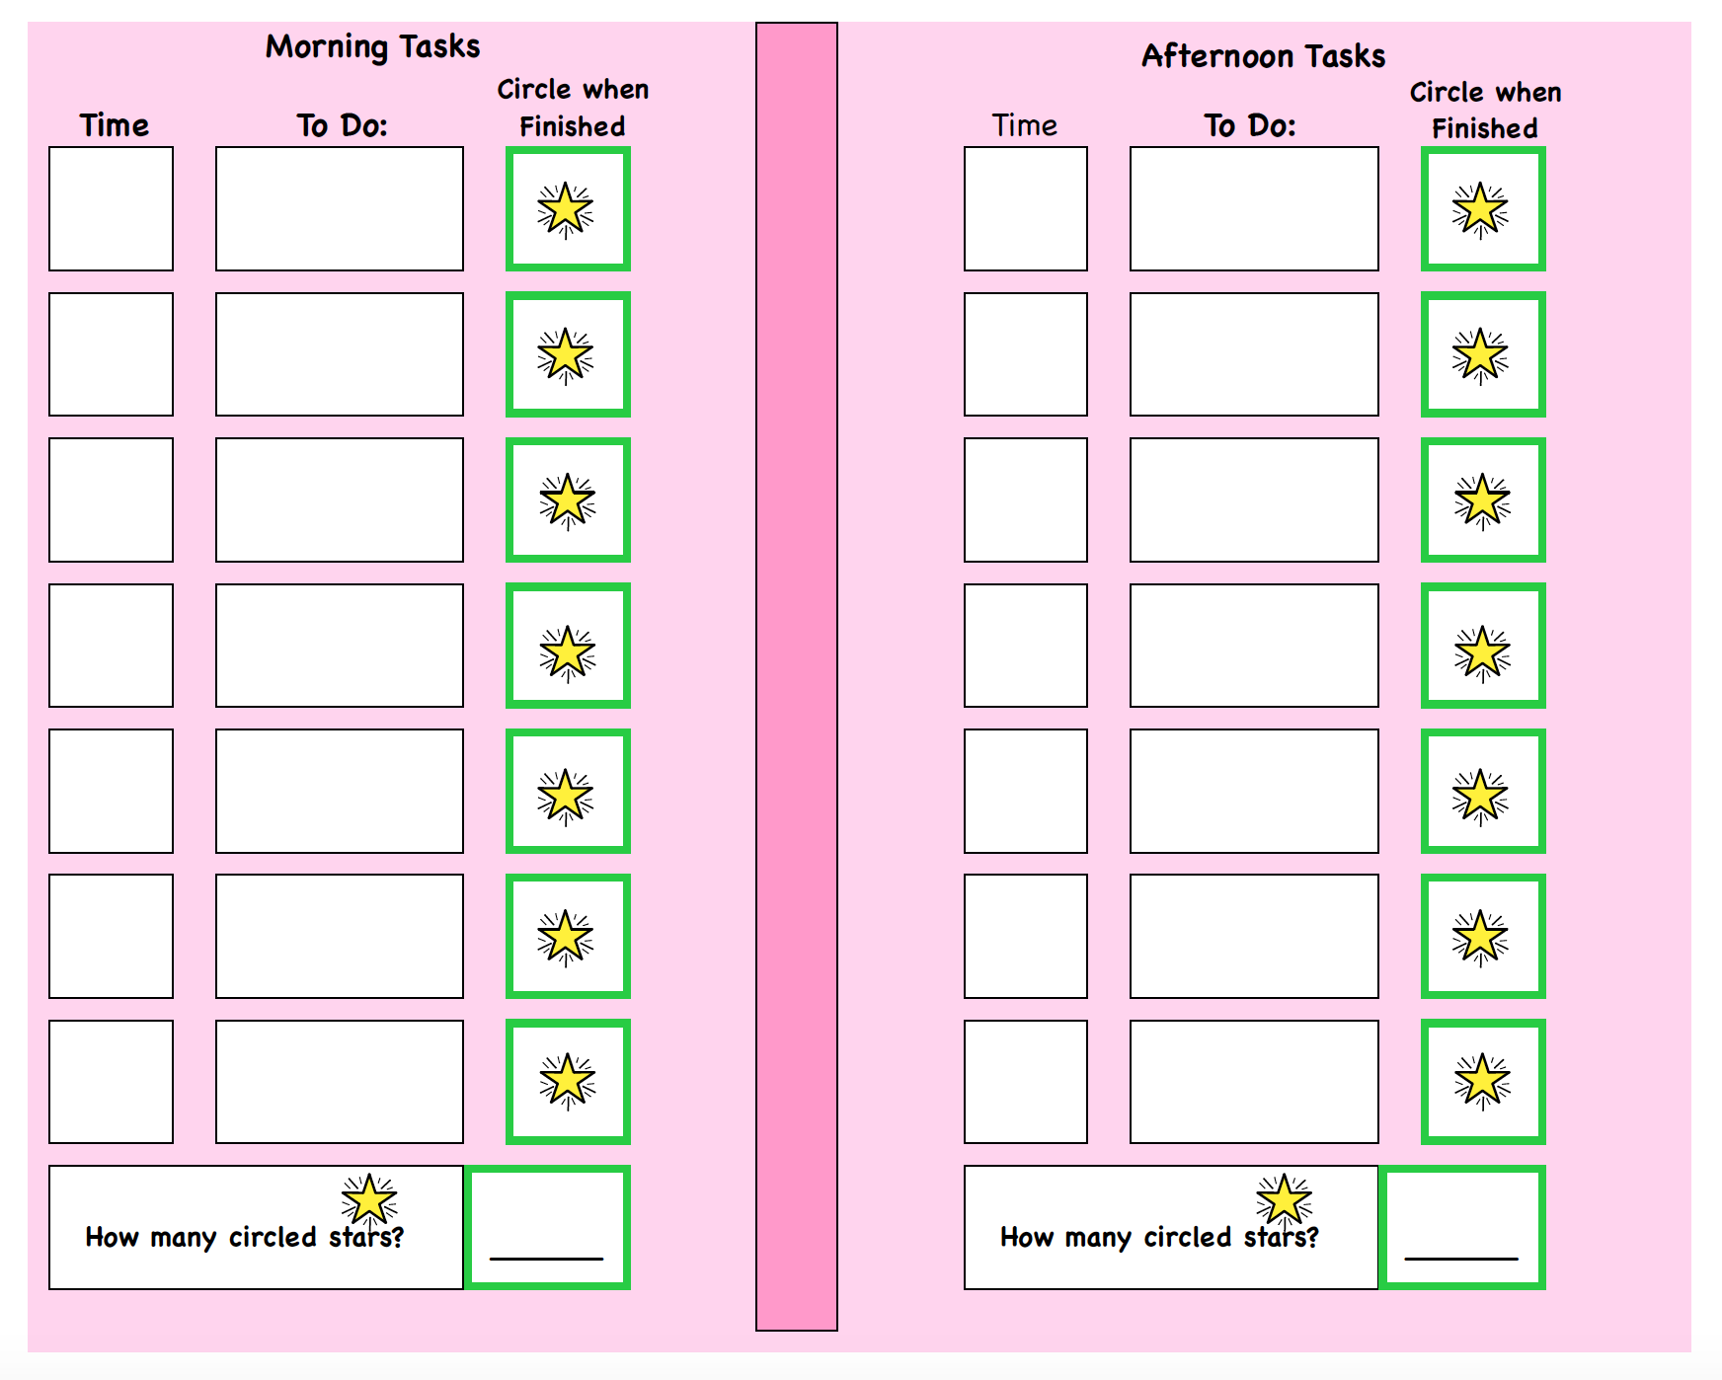

Figure 2. Sample First-Then Chart
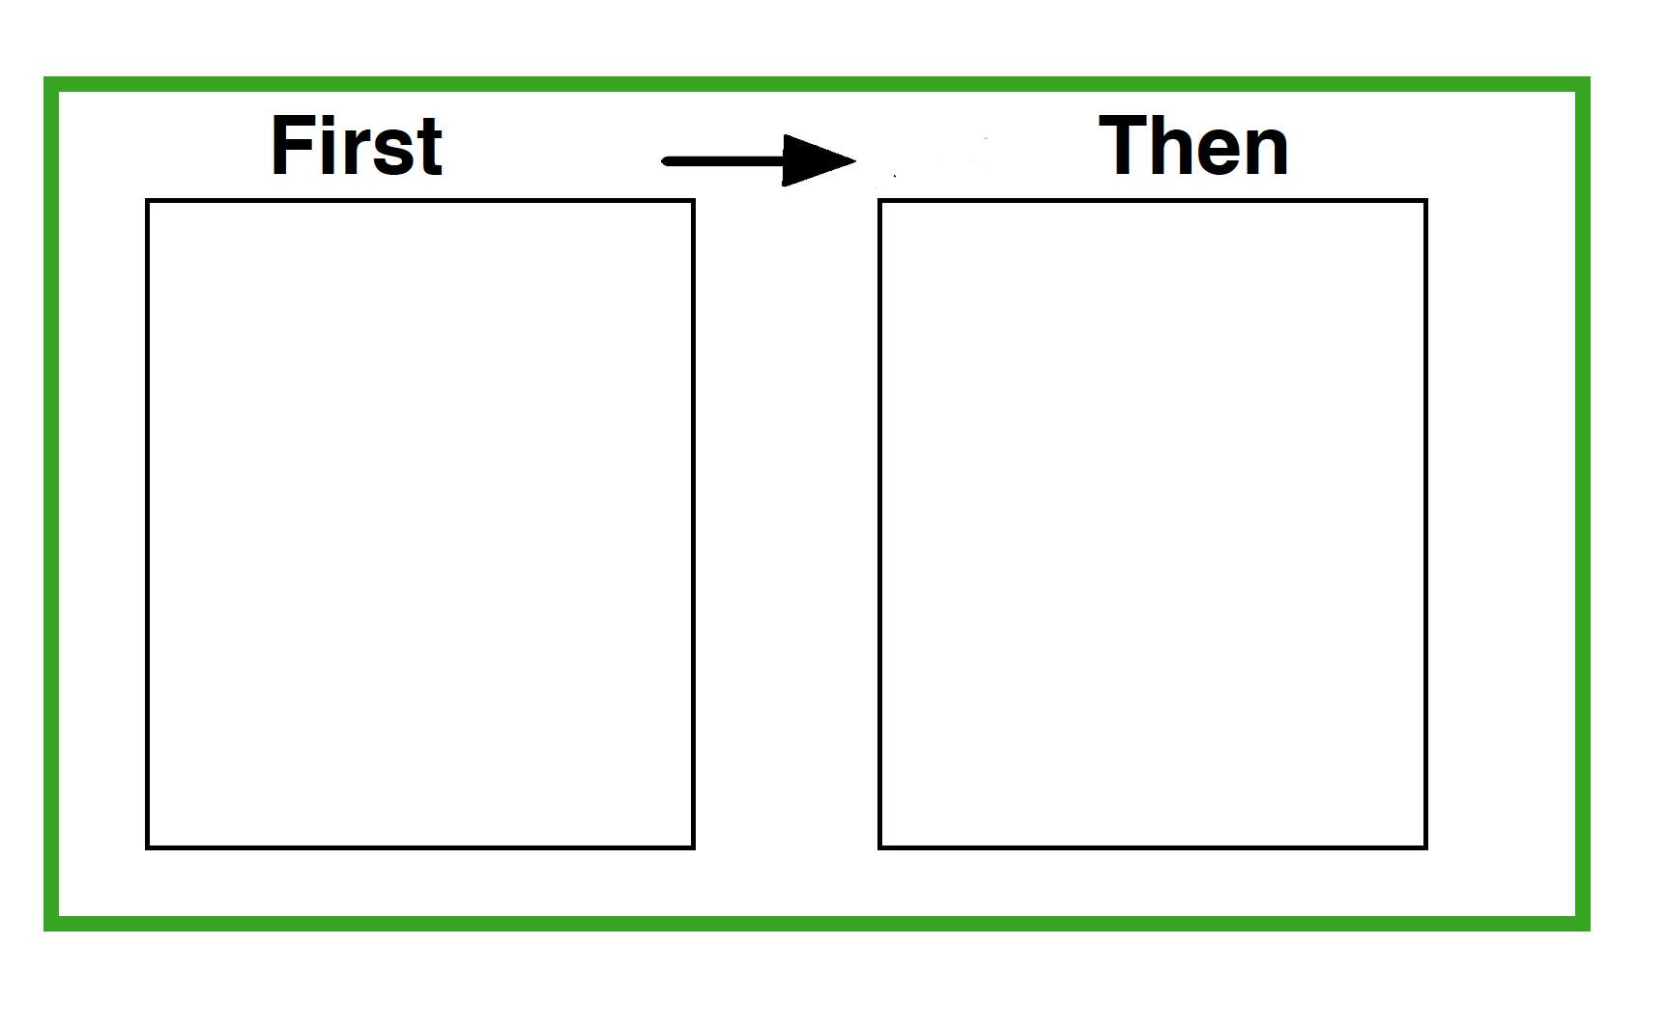

Figure 3. Images for First-Then Chart

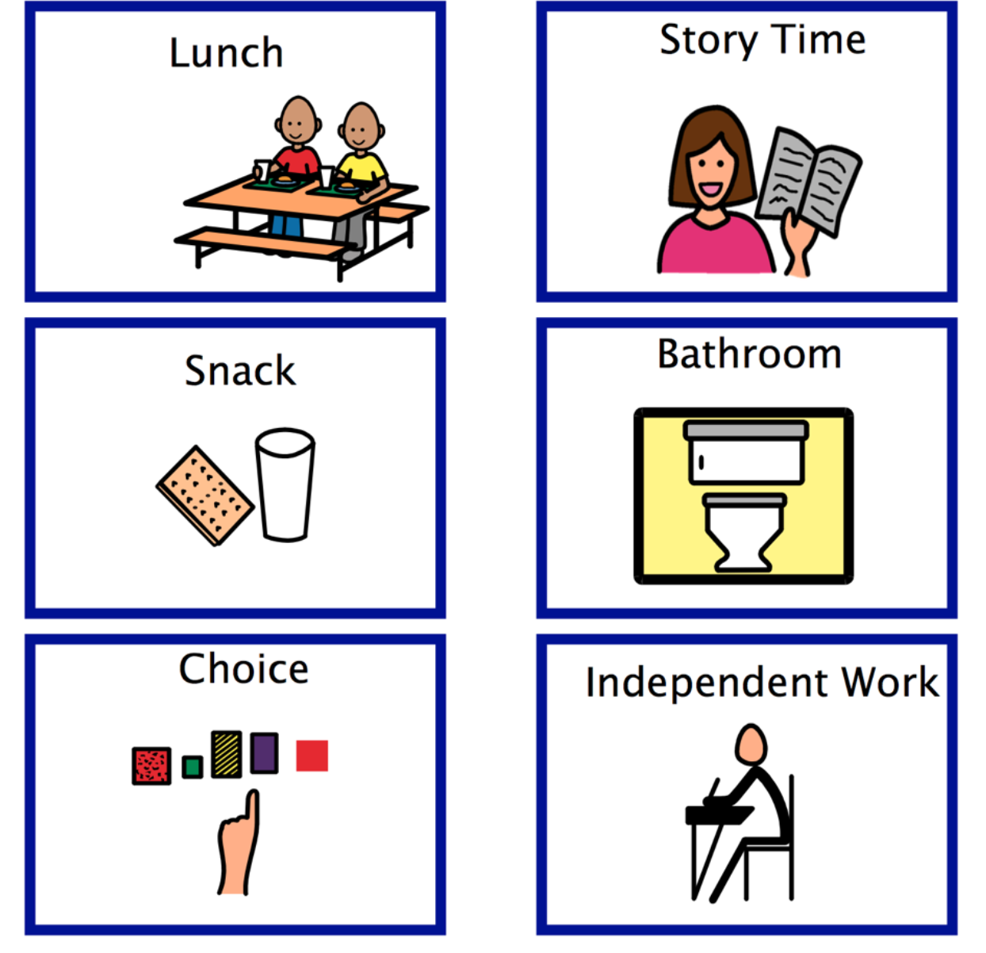
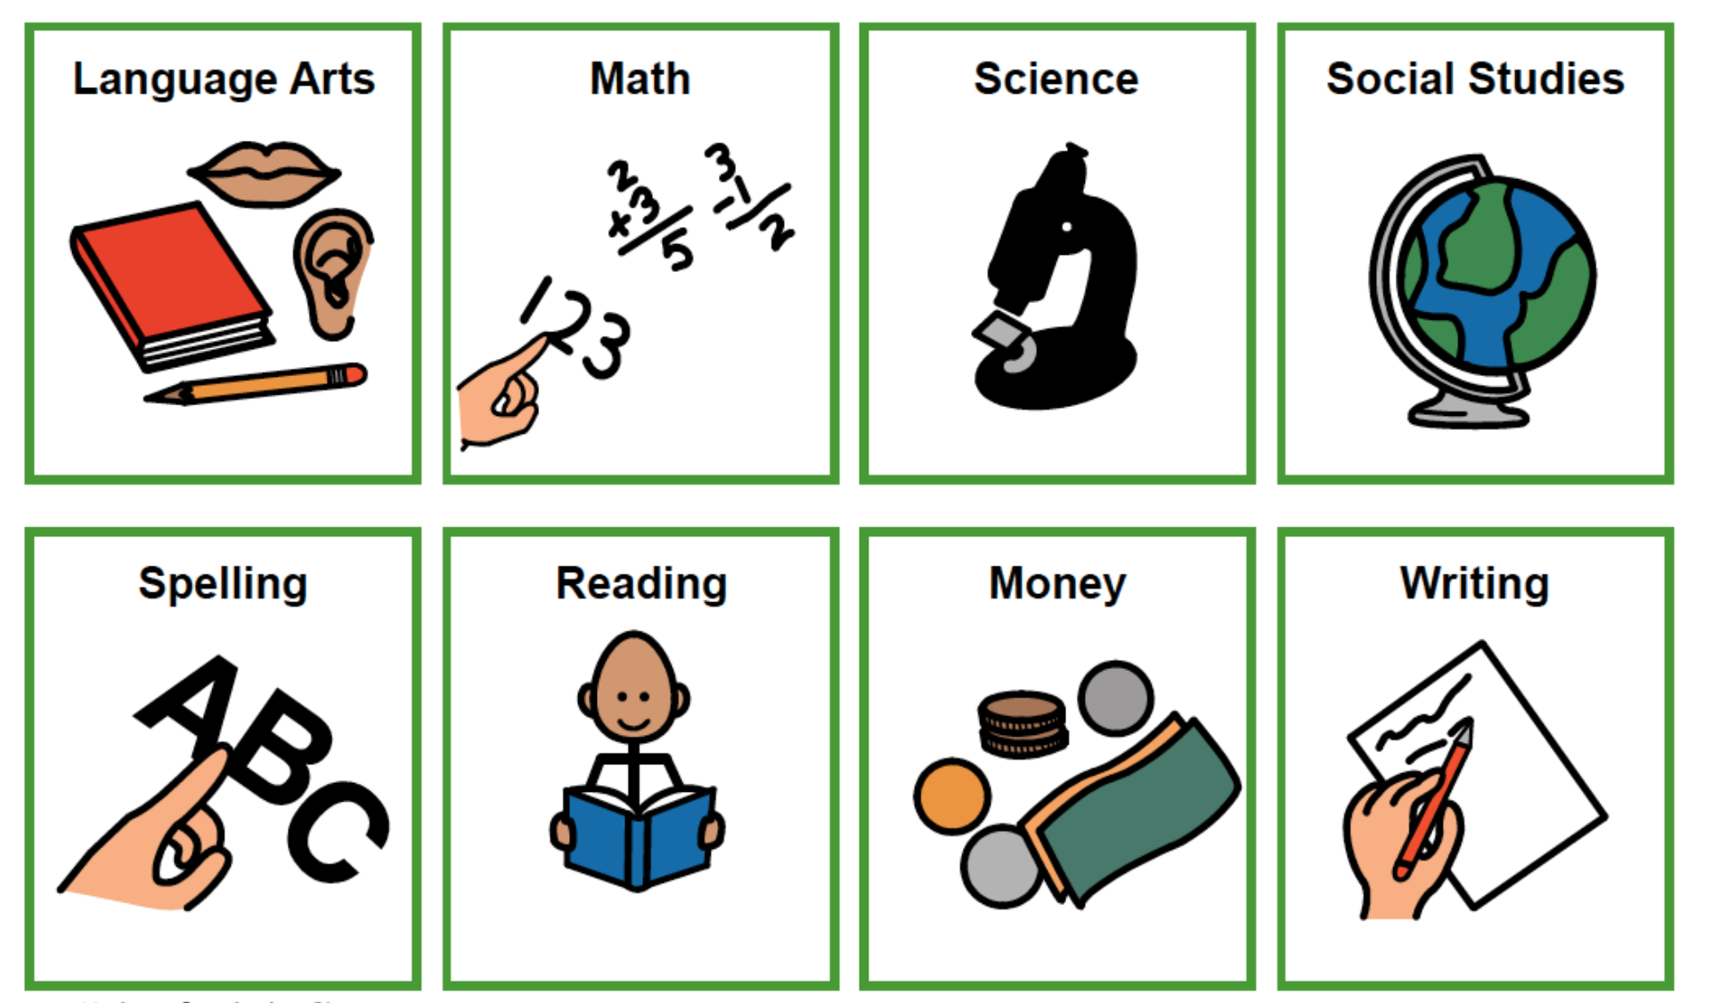

Figure 4. Sample Behavior Star Chart

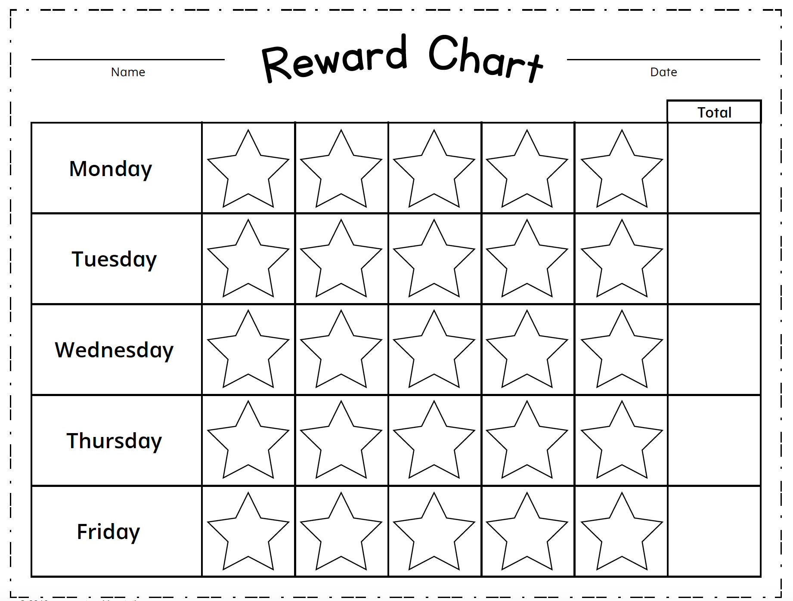

Figure 5. Sample Behavior Awareness Cards

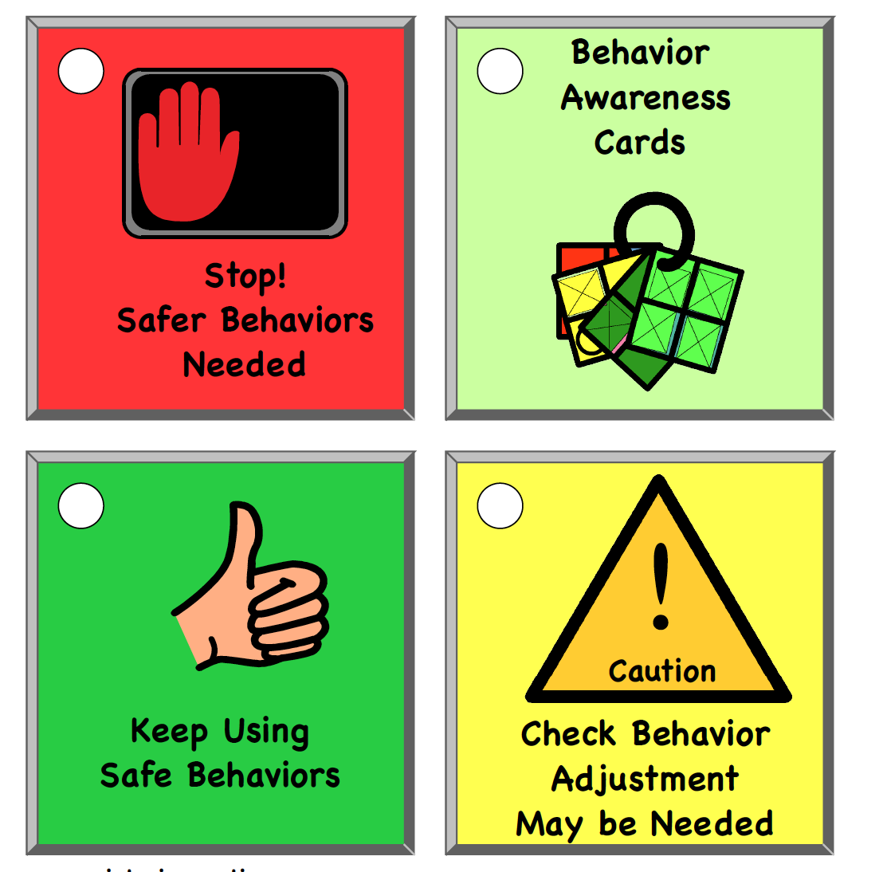

Figure 6. Sample Break Card

