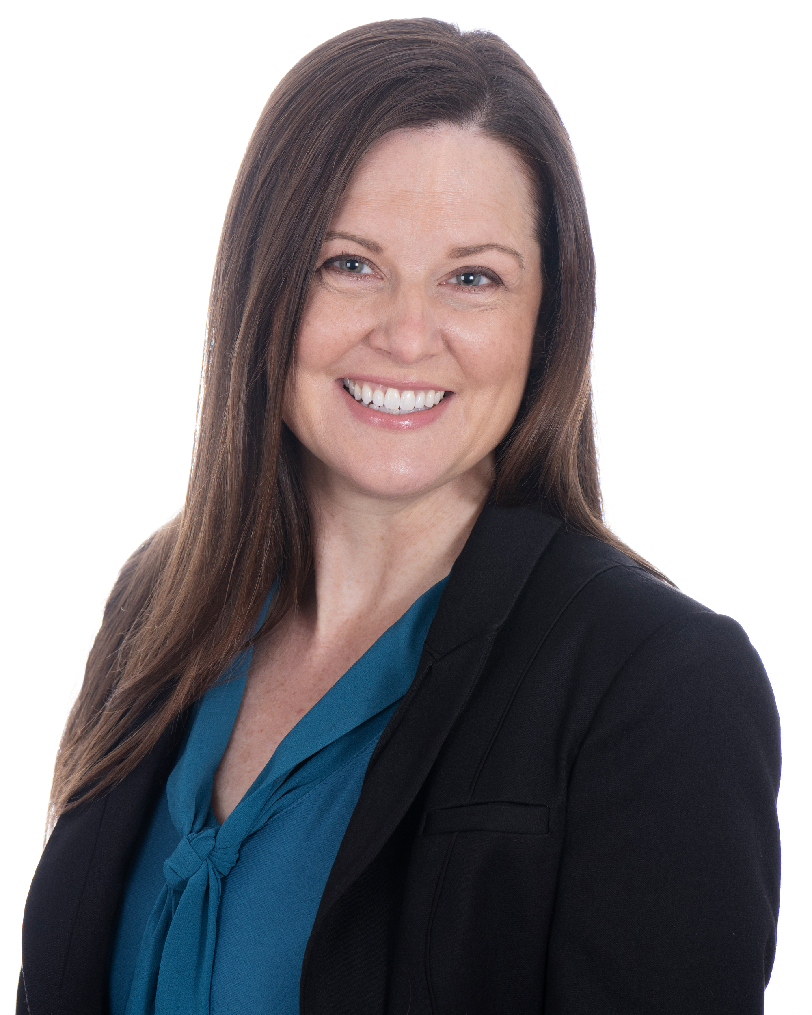
Central Bucks School Psychologist Recognized as National School Psychologist of the Year
Robyn Graham Photography

Congratulations to the National School Psychologist of the Year

Dr. Julia Szarko

Check out an interview with Dr. Szarko on ASPP’s YouTube channel.

Watch Dr. Szarko’s remarks upon receiving her award from the National Association of School Psychologists.

Dr. Szarko is a truly outstanding school psychologist. She exemplifies the full spectrum of school psychologist responsibilities. Not only does Dr. Szarko evaluate individual students to identify their needs, she also provides systemic academic, behavioral, and social-emotional supports across the school system. She is integral to her schools’ development of system-wide initiatives to promote academic success and behavioral supports, as well as her schools’ suicide prevention and crisis response management. She trains and coaches teachers to improve classroom management for all students, and she provides specific interventions for individual students with more intensive needs. In addition to working to prevent problems in the school setting, Dr. Szarko goes above and beyond to resolve challenges when they arise. In response to school crises, Dr. Szarko delivers immediate response and assistance with empathy and understanding.
Dr. Szarko’s passion for school psychology and supporting students’ mental health needs is evident through her leadership and advocacy at the local, state, and national levels. At the local level, she is partnering with her Union President to build alliances across the region that will increase school mental health supports. At the state level, Dr. Szarko is an active member of the ASPP Executive Board. In this role, Dr. Szarko has developed working relationships with state and federal legislators to address students’ mental health needs. Two of her most recent efforts have been to (a) update the school psychologist Pennsylvania State Certification to reflect the National Association of School Psychologists practice model, and (b) draft bills to address the school psychologist shortage, such as the HR 4025 Mental Health in Schools Excellence Program Act of 2019, which will assist in recruitment and funding for trainees. At the national level, Dr. Szarko has expanded her advocacy efforts as a member of the NASP Government and Professional Relations Committee.
Dr. Szarko is well-respected by her graduate trainees, colleagues, students, and parents. She is described as a compassionate, genuine professional who advocates for students’ mental health and social-emotional needs. Dr. Szarko’s respect for students and parents is evident in the strong relationships that she builds and maintains with families, and the families’ high regard for her recommendations.
Dr. Szarko is a truly exemplary school psychologist. Please join ASPP in celebrating Dr. Szarko’s achievement as NASP School Psychologist of the Year!

